ᜉᜋn=tsN= Es=tdo nN= Is=l nN bohol=

**Bohol Island State University**

**mlkeN= pAdln= s Ag=sikpn= At= Ad=kitek=tod**

**College of Engineering and Architecture**

PRASSIGNMENT

**C – PROGRAMMING**

FEBRUARY 20, 2019

CPRRTRFHSCCCPPRC

|  |
| --- |
| GIRLEY KAY SUAREZ |
| **baapto 1**  **BSCpE 1** |

|  |
| --- |
| Ag=sekp= m.A. peden=  ENGR. M.A. PERIN |
| **Tgpg=todoo**  **INSTRUCTOR** |

***What is #include<iostream>?***

* <iostream> is a header file. This file defines the cin, cout, cerr and clog objects, which corresponds to the standard input stream, the standard output stream, the un-buffered standard error stream, and the buffered standard error stream, respectively.

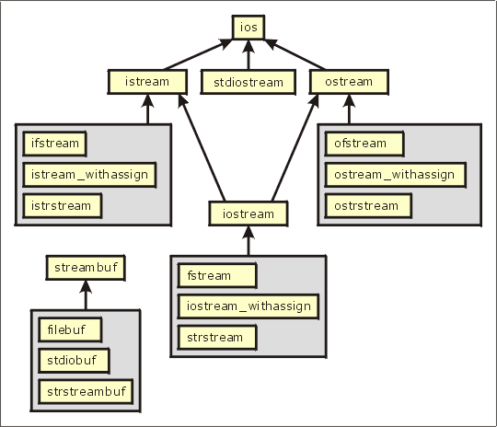

***#The include<iostream> CODE:***

// Standard iostream objects -*- C++ -*-

// Copyright (C) 1997-2013 Free Software Foundation, Inc.

//

// This file is part of the GNU ISO C++ Library. This library is free

// software; you can redistribute it and/or modify it under the

// terms of the GNU General Public License as published by the

// Free Software Foundation; either version 3, or (at your option)

// any later version.

// This library is distributed in the hope that it will be useful,

// but WITHOUT ANY WARRANTY; without even the implied warranty of

// MERCHANTABILITY or FITNESS FOR A PARTICULAR PURPOSE. See the

// GNU General Public License for more details.

// Under Section 7 of GPL version 3, you are granted additional

// permissions described in the GCC Runtime Library Exception, version

// 3.1, as published by the Free Software Foundation.

// You should have received a copy of the GNU General Public License and

// a copy of the GCC Runtime Library Exception along with this program;

// see the files COPYING3 and COPYING.RUNTIME respectively. If not, see

// <http://www.gnu.org/licenses/>.

/** @file include/iostream

* This is a Standard C++ Library header.

*/

//

// ISO C++ 14882: 27.3 Standard iostream objects

//

#ifndef _GLIBCXX_IOSTREAM

#define _GLIBCXX_IOSTREAM 1

#pragma GCC system_header

#include <bits/c++config.h>

#include <ostream>

#include <istream>

namespace std _GLIBCXX_VISIBILITY(default)

{

_GLIBCXX_BEGIN_NAMESPACE_VERSION

/**

* @name Standard Stream Objects

*

* The &lt;iostream&gt; header declares the eight <em>standard stream

* objects</em>. For other declarations, see

* http://gcc.gnu.org/onlinedocs/libstdc++/manual/bk01pt11ch24.html

* and the @link iosfwd I/O forward declarations @endlink

*

* They are required by default to cooperate with the global C

* library's @c FILE streams, and to be available during program

* startup and termination. For more information, see the HOWTO

* linked to above.

*/

//@{

extern istream cin; /// Linked to standard input

extern ostream cout; /// Linked to standard output

extern ostream cerr; /// Linked to standard error (unbuffered)

extern ostream clog; /// Linked to standard error (buffered)

#ifdef _GLIBCXX_USE_WCHAR_T

extern wistream wcin; /// Linked to standard input

extern wostream wcout; /// Linked to standard output

extern wostream wcerr; /// Linked to standard error (unbuffered)

extern wostream wclog; /// Linked to standard error (buffered)

#endif

//@}

// For construction of filebuffers for cout, cin, cerr, clog et. al.

static ios_base::Init __ioinit;

_GLIBCXX_END_NAMESPACE_VERSION

} // namespace

#endif /* _GLIBCXX_IOSTREAM */

**What does ‘int(main)’ means?**

The purpose of **main** 's return value is to return an exit status to the operating system. In standard C, the only valid signatures for **main** are: **int main**(void) and **int main**(**int** argc, char **argv) The form you're using: **int main()** is an old style declaration that indicates **main** takes an unspecified number of arguments.

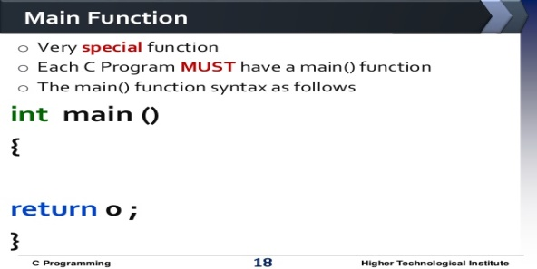

**“What does namespace means in c++ program?”**

A **namespace** is a declarative region that provides a scope to the identifiers (the names of types, functions, variables, etc) inside it. Namespaces are used to organize code into logical groups and to prevent name collisions that can occur especially when your code base includes multiple libraries. All identifiers at namespace scope are visible to one another without qualification. Identifiers outside the namespace can access the members by using the fully qualified name for each identifier, for example std::vector<std::string> vec;, or else by a [using Declaration](https://docs.microsoft.com/en-us/cpp/cpp/using-declaration?view=vs-2017) for a single identifier (using std::string), or a [using Directive](https://docs.microsoft.com/en-us/cpp/cpp/namespaces-cpp?view=vs-2017#using_directives) for all the identifiers in the namespace (using namespace std;). Code in header files should always use the

* When you make a call to using namespace <some_namespace>; all symbols in that namespace will become visible without adding the namespace prefix. A symbol may be for instance a function, class or a variable.

E.g. if you add using namespace std; you can write just cout instead of std::cout when calling the operator cout defined in the namespace std.

* This is somewhat dangerous because namespaces are meant to be used to avoid name collisions and by writing using namespace you spare some code, but loose this advantage. A better alternative is to use just specific symbols thus making them visible without the namespace prefix. Eg:

#include <iostream>

using std::cout;

int main() {

cout << "Hello world!";

return 0;

}

**-*girlayy***